

VERTICAL DIFFUSION PM PROCEDURE (Nitride)
PM Type: BPM – Big PM Prepared by:
Machine: LP-Nitride Robin 羅彬森
PM Frequency: Thick(Ni) = 120大PM S200 FURNACE
Thin(Ni) = 300大PM Date: March 2017
Note: Clean APC and MV every 4th BPM

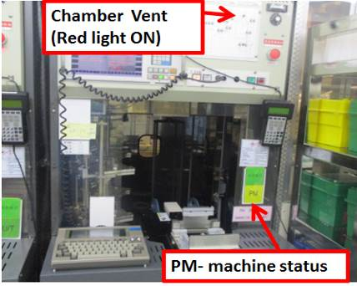 |  | 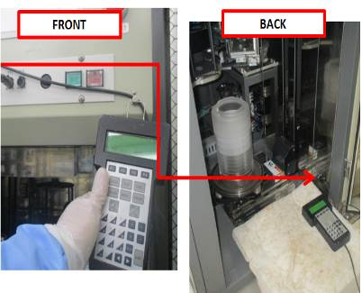 |  | 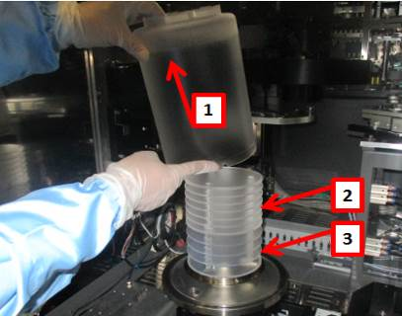
1. Confirm if machine ready for PM, check if machine already vent |  | 2. Get controller from front of machine, and connect to back terminal on lower right side. |  | 3. Remove pedestal cover +7fins+5fins and bring to parts cleaning area

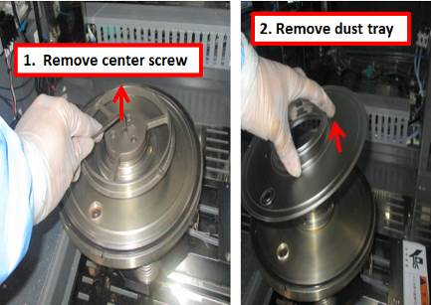 |  | 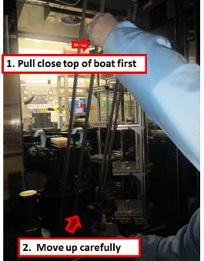 |  | 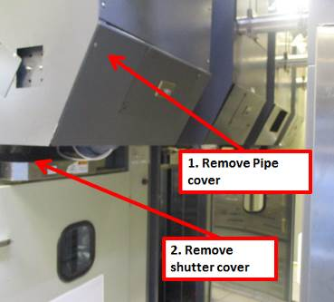
4. Remove dust tray |  | 5. Remove boat |  | 6. Remove back machine cover, and remove shutter cover

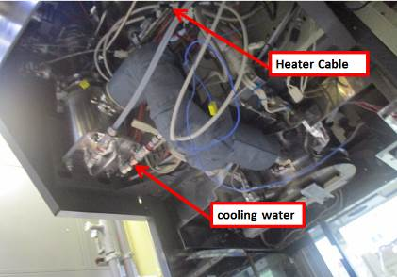 |  | 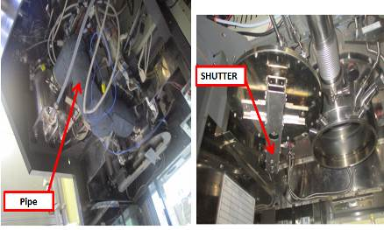 |  | 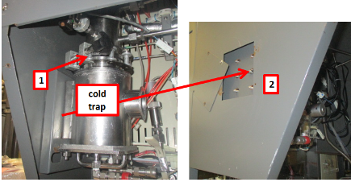
7. Disconnect pipe heater power and manifold cooling water fittings |  | 8. Remove pipe, and shutter |  | 9. Remove cold trap, disassemble and bring to cleaner machine

Doc. #: 2017-CRP-006 rev.00 Page 1 of 4

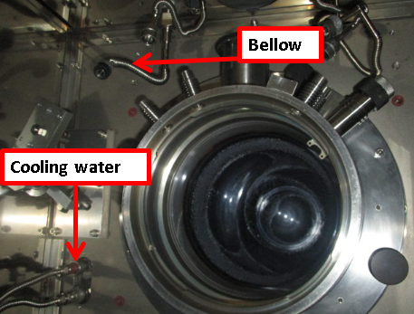 |  | 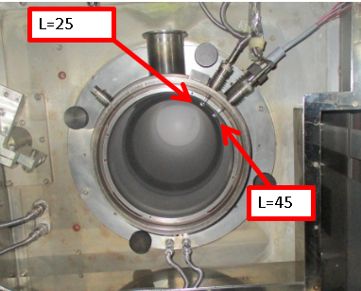 |  | 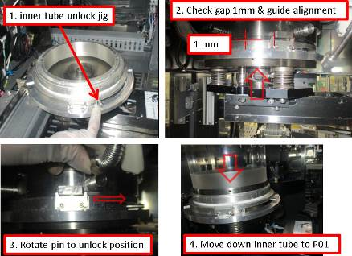
10. remove bellow connection and detach manifold cooling water fittings |  | 11. remove L25 and L45 injectors |  | 12. Place inner tube jig in boat lifter and move up to get inner tube

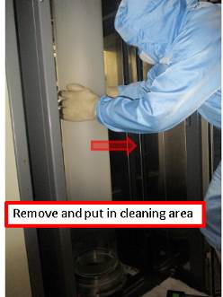 |  | 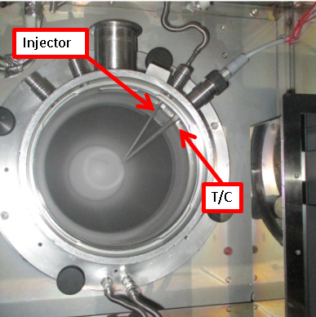 |  | 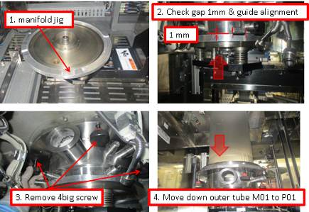
13. Using safety gloves remove inner tube and bring to cleaning area using push cart. |  | 14. remove L500 injector and T/C r |  | 15 bring down manifold & outer tube using manifold jig

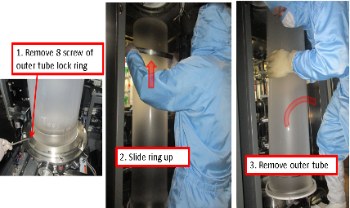 |  | 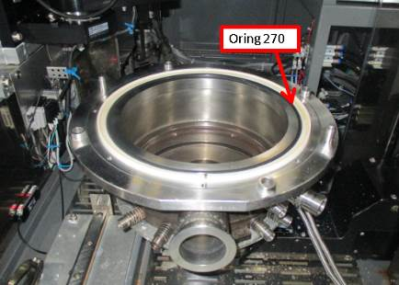 |  | 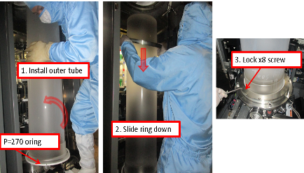
16 remove outer tube from manifold using safety gloves and bring to cleaning area |  | 17. Remove old manifold, Replace by NEW / CLEAN parts. |  | 18. Install outer tube and lock. Use P270 oring

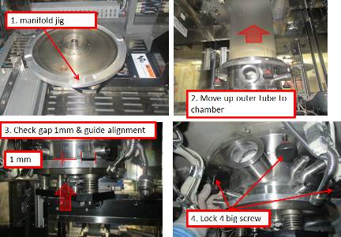 |  |  |  | 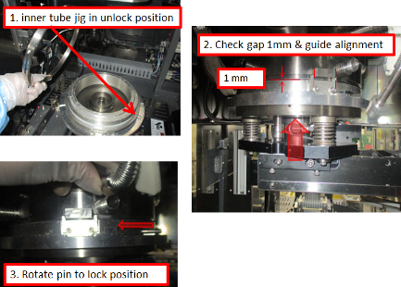
19. Move up and lock manifold in place. Then bring down lifter to P01 |  | 20. Install L500 injector and T/C use new oring P20 and P12 |  | 21. Install inner tube

Doc. #: 2017-CRP-006 rev.00 Page 2 of 4

 |  |  |  | 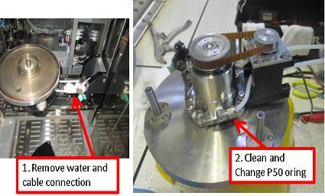
22. install L25 and L45 injectors use new P12 oring |  | 23. install new bellow and connect manifold cooling water, change gasket and P12 oring |  | 24. Clean M06 boat rotate motor  Change new Oring, then install again.

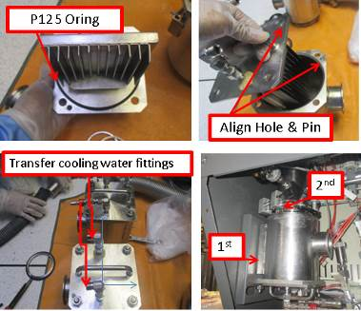 |  | 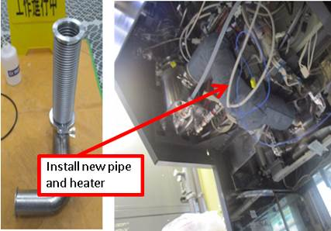 |  | 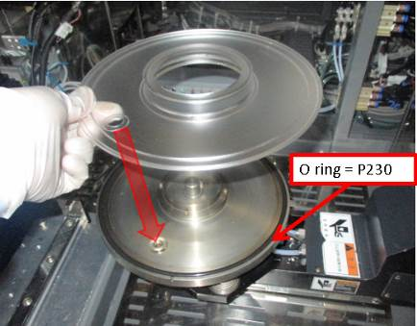
25. Assemble and install new clean cold trap |  | 26. Assemble and install new pipe |  | 27. Install dust tray

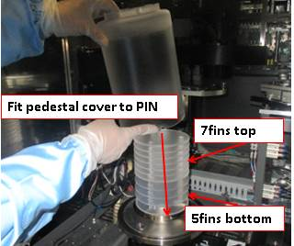 |  | 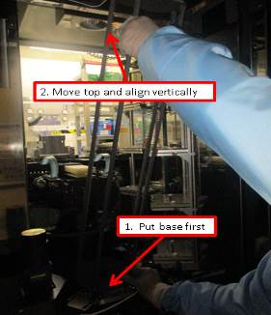 |  | 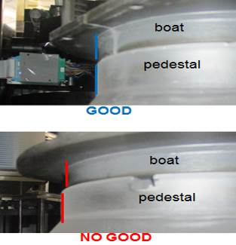
28. Install pedestal |  | 29. Install boat |  | 30. Put M06 in P01, put boat on top of pedestal and check alignment

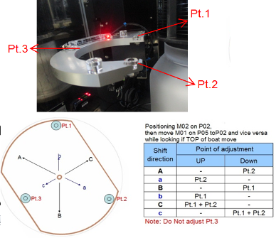 |  | 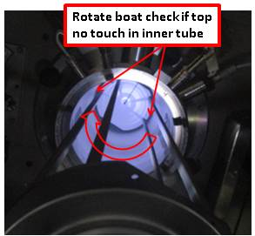 |  | 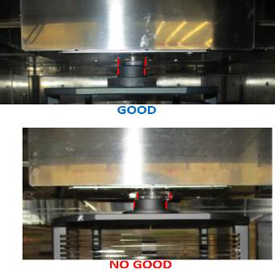
31. while M02 is in P02, Move M01 between P02 and P05, adjust if top of boat move |  | 32. Check chamber and boat gap, move boat at Ht.=1000 and rotate360deg |  | 33. Put M02 in P01 to check/adjust boat lock

Doc. #: 2017-CRP-006 rev.00 Page 3 of 4

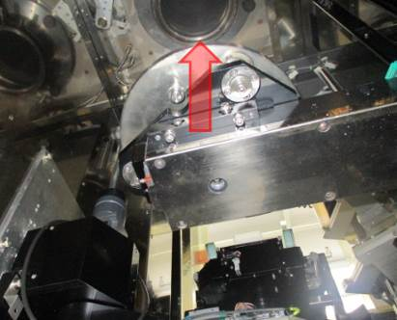 |  | 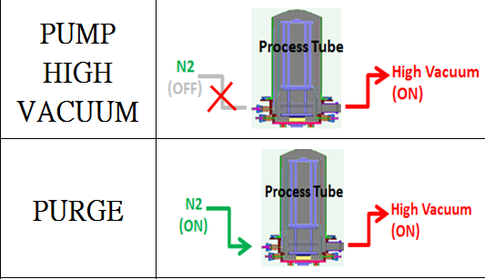 |  | 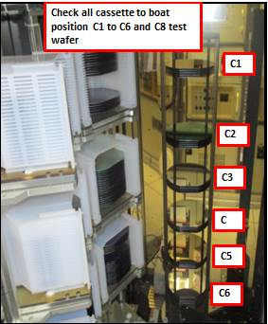
34. Move Chamber lid up to close chamber |  | 35. pump vacuum, purge 20mins and do leak test <0.2 Torr/130sec For low temp (boat outside chamber) |  | 36. Put boat M02 in P01 to do Transfer check. Load dummy wafer

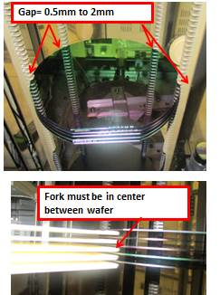 |  | 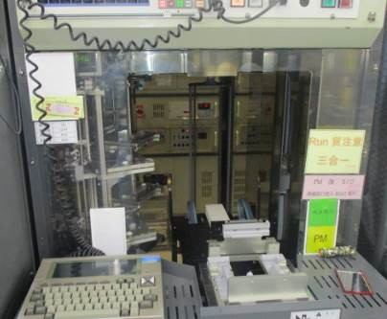 |  | 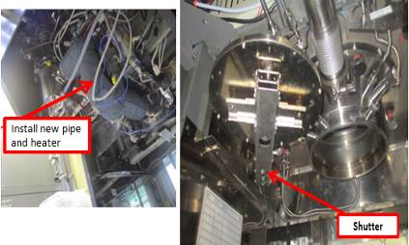
37. Check/adjust wafer position on boat, and fork gap between wafers |  | 38. Unload dummy wafer and cassette. |  | 39. Install Pipe heater and shutter cover, check shutter movement. Move boat inside chamber.

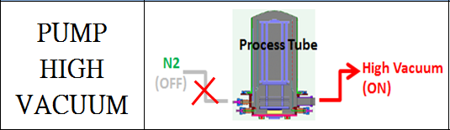 |  | 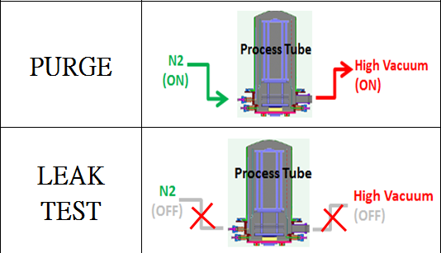 |  | 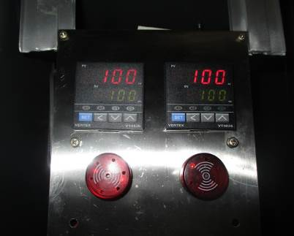
40. move boat inside chamber and pump vacuum to 0.00 Torr |  | 41. Open heater and purge 1hr, then leak test at High temperature <0.2 Torr in 130secs.(boat inside chamber) |  | 42. Check and adjust heater temperature settings at back of machine.

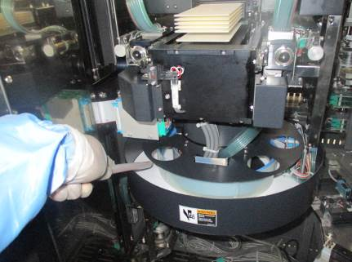 |  | EA TEST RUN
43. Clean and Vacuum inside machine and Transfer robot area before close machine |  | 44. fill up machine log book PM OK and endorse to EA for test run
Doc. #: 2017-CRP-006 rev.00 Page 4 of 4

